

**FPT ACADEMY INTERNATIONAL**

**FPT – APTECH COMPUTER EDUCATION**

**Vinegar Food Restaurant**

**WEBSITE**

|  |  |  |  |
| --- | --- | --- | --- |
| **Center Name** | | ACE-HCMC-2-FPT  Address: 590 Cach Mang Thang Tam, District 3, Ho Chi Minh City | |
| **Instructor** | | Mr. Nguyen Van Binh & Mr. Ngo Phuoc Nguyen | |
| **Class** | | T1.2005.E3 | |
| **Group** | | 1 | |
| **Group members** | | **Name** | **Student ID** |
| Hoang Huu Nghia | Student1268270 |
| Nguyen Thien Quan | Student1267396 |
| Vu Ba Thai An | Student1267392 |
| **Duration** | **Start date** | 1st Aug 2020 | |
| **End date** | 1st Sep 2020 | |

**This is to certify that**

**Mr./Ms.:**

Hoang Huu Nghia

Nguyen Thien Quan

Vu Ba Thai An

**has successfully designed & developed**

eProject: Vinegar Food Restaurant website

**Submitted by:**

Hoang Huu Nghia

**Date of issue:**

**Authorized Signature:**

**TABLE OF CONTENTS**

ACKNOWLEDGEMENT 5

SYNOPSIS 5

PROBLEM STATEMENT 6

CUSTOMER'S REQUIREMENTS SPECIFICATIONS 7

SCOPE OF THE WORK (IN BRIEF) 8

TASK SHEET REVIEW 1 9

SITE MAP 10

MOCK OF THE WEBSITE 11

1. Home page 12

2. Meals (Regular, Lunch, Dessert, Beverages) 14

TASK SHEET REVIEW 2 15

WEBSITE DESCRIPTION 16

1. Home page 16

2. Awards 16

3. Gallery 17

4. Recipe 17

5. Catering 18

6. About team development 18

7. Contact 19

8. Meals 19

JAVASCRIPT DESCRIPTION 22

1. Button to top 22

2. Bottom Navigation appears when scroll 22

3. Bottom Navigation responsive tranforms navigation center 23

4. Addition 24

TASK SHEET REVIEW 3 29

CHECK REQUIREMENTS OF REPORT 30

CHECK REQUIREMENTS OF WEBSITE 31

ACKNOWLEDGEMENT

Teaching is a noble profession, with the responsibility of imparting knowledge and experience to students. We have spent more than 2 months studying at FPT Aptech and we would like to take this opportunity to thank our deceased teacher Mr. Nguyen Van Binh, the teacher has accompanied and instructed during the past time. Also, we would like to thank the current teacher Mr. Ngo Phuoc Nguyen.

Thank you also to Aptech India for giving us the opportunity to implement this eProject, so that we can apply what we have learned in practice and gain practical experience.

SYNOPSIS

Vinegar Food Restaurant which is the flagship brand of JADONS Ltd (Limited Liability Company) has spread over its aroma in this industry over the past few decades. Known as “the Serving plates” with 72 different rotating menus and 240000 delicacies throughout the country.

Vinegar Food Restaurant came to Vietnam and wanted to create a website to highlight elements such as:

* There is banquet service in the restaurant with luxurious rooms for group party parties, cozy for family parties, and a large lobby for wedding or company parties.
* Restaurant also has ouside catering.
* Includes Chinese Western dishes.

PROBLEM STATEMENT

After reading the requirements from Jadons Ltd, our group has discussed about what should to be done to fulfill them properly. We came to conclusion that in order to achieve the best result, we should deal with following queries:

1. How many tabs should be displayed?

* 5 pages:
  + Homepage includes sections: About team + Awards + Gallery + Recipe of the month; Catering; Contact us + Feed back
  + Regular meals page .
  + Lunch meals page .
  + Snacks meals page .
  + Dessert meals page .
  + Beverages meals page .

1. How is each web page designed to offer users the enjoyable experience?

* The main color of the background is simple color to emphasize the aroma of dish.
* Each page will have the same header and footer bar so the page turns smoothly without dizzying users.

1. Who are web users interact with the website?

* The users are people who are well-off. The website has to be both eye-catching and easily, quickly manipulated for them.

1. What browsers can the website be run on?

* The website will be built to run efficiently only on Windows platform. However, it still can be compatible on leading web browser such as Chrome

# 

CUSTOMER'S REQUIREMENTS SPECIFICATIONS

1. Client: Vinegar Food Restaurant website
2. Input to the system:

* **From webmaster:**
* Information about Vinegar Food Restaurant
* Dishes of restaurant
* Contact details
* **From web users:**
* Searching for contacts including address, email, phone numbers
* Referring dishes
* **Output from the system:**
* Form for user to feed back
* Images and recipe of dishes
* Images and information of catering

1. Hardware/ Software Requirements

* **For webmaster**

**Hardware**

* Intel Pentium 4 processor or higher
* 1 Gigabytes of RAM or higher

**Software**

* Windows 7 OS or higher
* Visual Studio Code and Webstorm
* HTML5 and Javascript supporting web browsers such as IE, Chrome or Firefox
* **For web users**

**Hardware**

* Intel Pentium 4 processor or higher
* 512 Megabytes of RAM or higher

**Software**

* Windows XP OS or higher
* HTML5 and Javascript supporting web browsers such as IE, Chrome or Firefox

SCOPE OF THE WORK (IN BRIEF)

After a long and detailed discussion, our group has decided to create a website contain the following webpages:

1. ***Homepage***: Display general information about Vinegar Food Restaurant with best sale dishes pictures in order to attract users in the best way.
2. **Awards:** Information details including awards, slogan,…
3. **Gallery + Recipe of month:** A lot of images dishes and recipe
4. **Contact + Feedback:** Display address, Geolocation, Feed back to team developer
5. **Catering:** Booking inside and outside party services (wedding party, seminar, event party); images about room for catering
6. **Meals:** Includes 5 subpages (regular, lunch, snacks, desert, beverages)

TASK SHEET REVIEW 1

|  |  |  |  |  |  |  |  |
| --- | --- | --- | --- | --- | --- | --- | --- |
| **Project Ref. No.:**  **eP/Advertisement** **Portal Management** **System/01** | | **Project Title:** | **Activity Plan** **Prepared** **By:** | **Date of Preparation of Activity Plan:** | | | |
| **Sr.No.** | **Task** | **Actual Start** **Date** | **Actual** **Days** | **Team** **Mate** **Names** | **Status** |
| 1 | Problem Statement | Vinegar Food Restaurant | Nghia + Quan + An | 1st Aug | 3 | Nghia | Finish |
| 2 | Analysis of Vinegar Food Restaurant requirements about the website | 1st Aug | 3 | Quan | Finish |
| 3 | The scope of the work (in brief) | 1st Aug | 3 | An | Finish |
| 4 | Task Sheet | 1st Aug | 4 | Nghia | Finish |

|  |  |
| --- | --- |
| Date: | |
| Signature of Instructor  **Mr. Ngo Phuoc Nguyen** | Signature of Team Leader  **Hoang Huu Nghia** |

SITE MAP

MOCK OF THE WEBSITE

We divide the website structure into layouts which will be displayed below. The header section includes Vinegar Food Restaurant logo and the Navigation Bar. Some tabs will have the pictures slideshow with the nice animation. The main content of each tab will be displayed in “Content” section. The footer includes Phone, Online Time, Email, Map.

## Home page

|  |
| --- |
| Content  **CATERING**  **HEADER**  **Meals navigation**  **RECIPE**  **AWARDS**  **GALLERY**  Recipe food  Recipe food  Recipe food  Recipe food  Recipe food  Picture  Picture  Picture  Picture  Picture |

**Home page (continue)**

|  |
| --- |
| **NAVIGATION BOTTOM**  **FOOTER**  **About team Development** |

## Meals (Regular, Lunch, Dessert, Beverages)

|  |
| --- |
| **NAVIGATION BOTTOM**  **FOOTER**  PICTURE  **Meals navigation**  **HEADER**  **(LOGO – NAVIGATION BAR)** |

TASK SHEET REVIEW 2

|  |  |  |  |  |  |  |  |
| --- | --- | --- | --- | --- | --- | --- | --- |
| **Project Ref. No.:**  **eP/Advertisement** **Portal Management** **System/01** | | **Project Title:** | **Activity Plan** **Prepared** **By:** | **Date of Preparation of Activity Plan:** | | | |
| **Sr.No.** | **Task** | **Actual Start** **Date** | **Actual** **Days** | **Team** **Mate** **Names** | **Status** |
| 1 | Site map | Vinegar Food Restaurant | Nghia | 9/8/20 | 1 | Nghia | Completed |
| 2 | Mock of the website | 9/7/20 | 2 | all | Completed |
| 3 | Task sheet | 9/8/20 | 1 | Nghia | Completed |

|  |  |
| --- | --- |
| **Date:** | |
| Signature of Instructor:  **Mr. Ngo Phuoc Nguyen** | Signature of Team Leader:  **Hoang Huu Nghia** |

WEBSITE DESCRIPTION

## Home page

1. *Description*

*First, the page will show a section with snow flew from below*

1. *Snapshot*

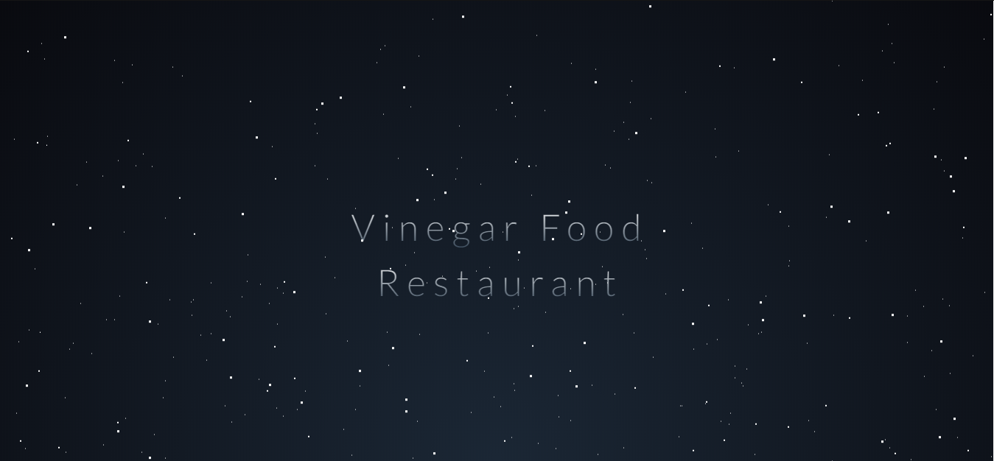

## Awards

1. *Description*

*The awards section provides information and received awards of Vinegar Food Restaurant.*

1. *Snapshot*

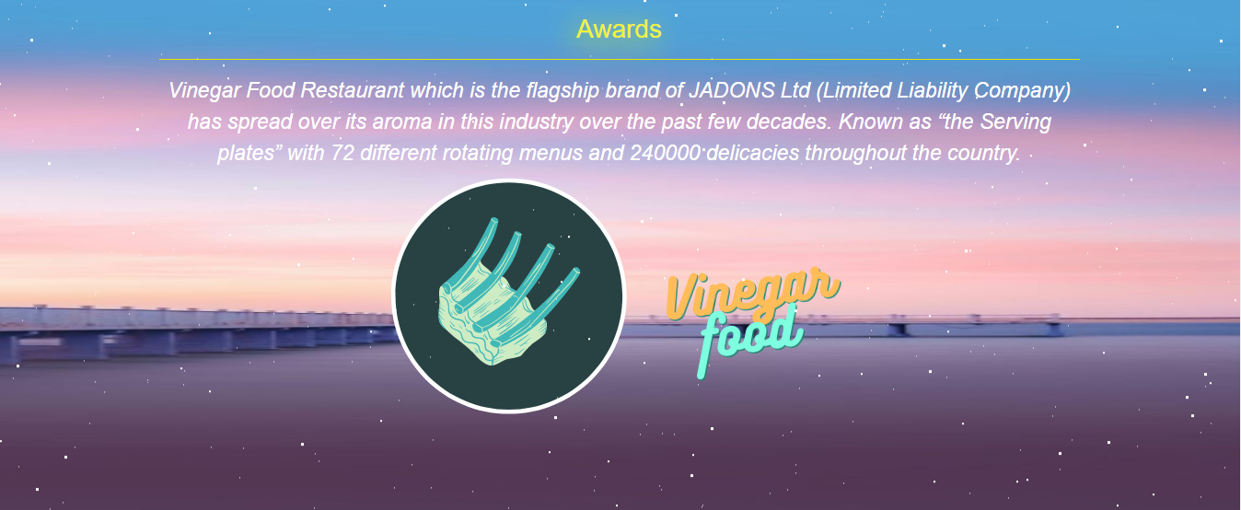

## Gallery

1. *Description*

*This section provides pictures of food.*

1. *Snapshot*

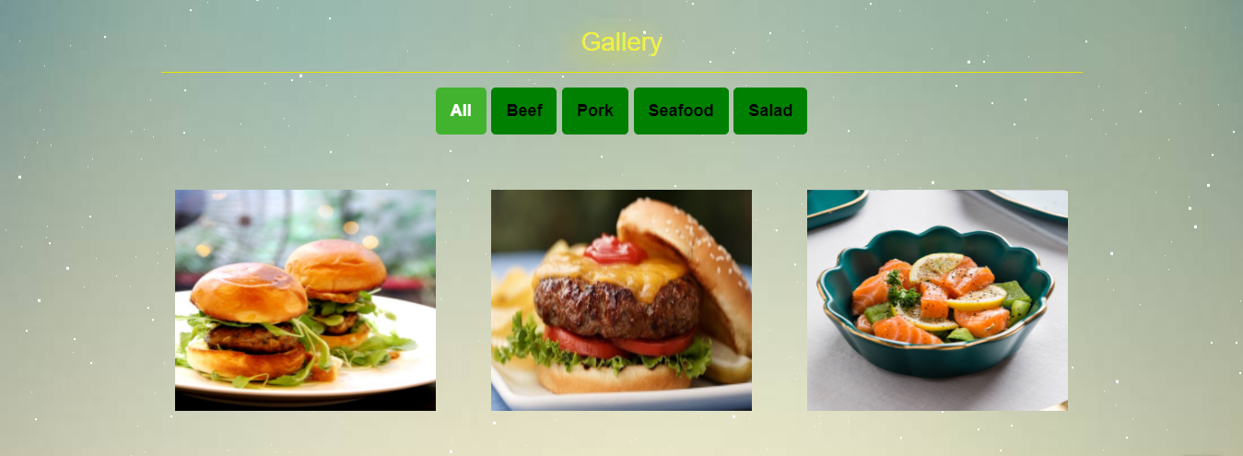

## Recipe

1. *Description*

*This section provides recipe of food every month.*

1. *Snapshot*

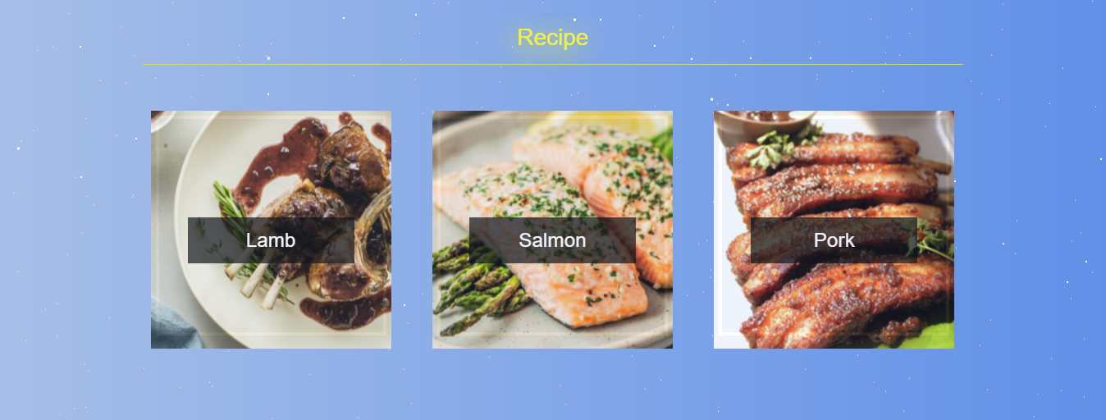

## Catering

1. *Description*

*This section provides inside and outside catering, books catering..*

1. *Snapshot*

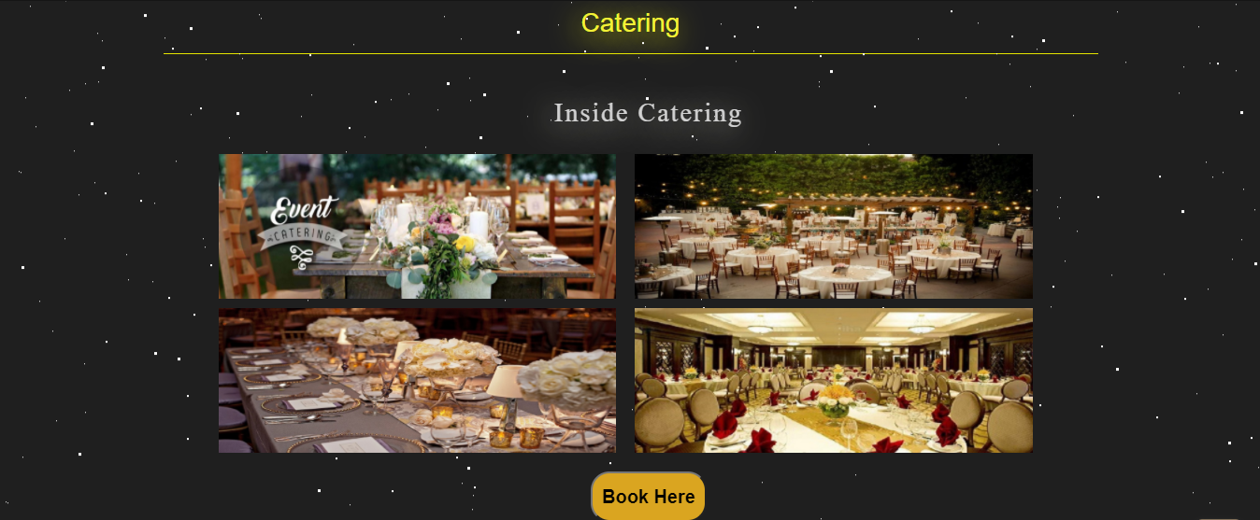

## About team development

1. *Description*

*This section provides members pictures*

1. *Snapshot*

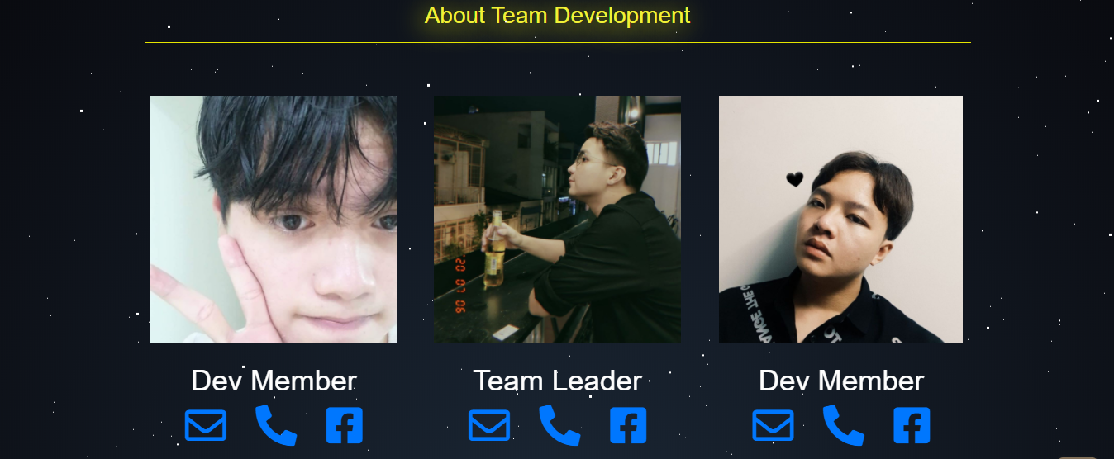

## Contact

1. *Description*

*This section provides inside and outside catering, books catering..*

1. *Snapshot*

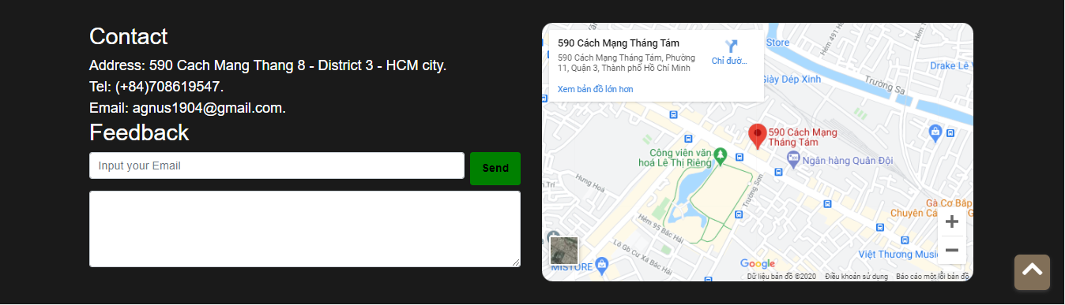

## Meals

*Description*

*Meals includes 5 pages (Regular, Lunch, Snacks, Dessert, Beverages). Each page shows pictures and name of dishes for each meals. The navigation of every page is same, includes: top navigation – fixed bottom navigation – Meals navigation.*

***Top of Regular page:***

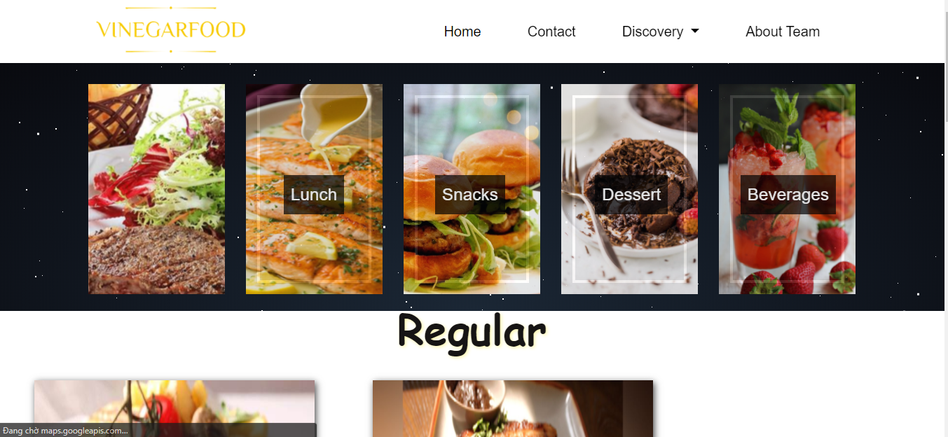

***Bottom of Regular page:***

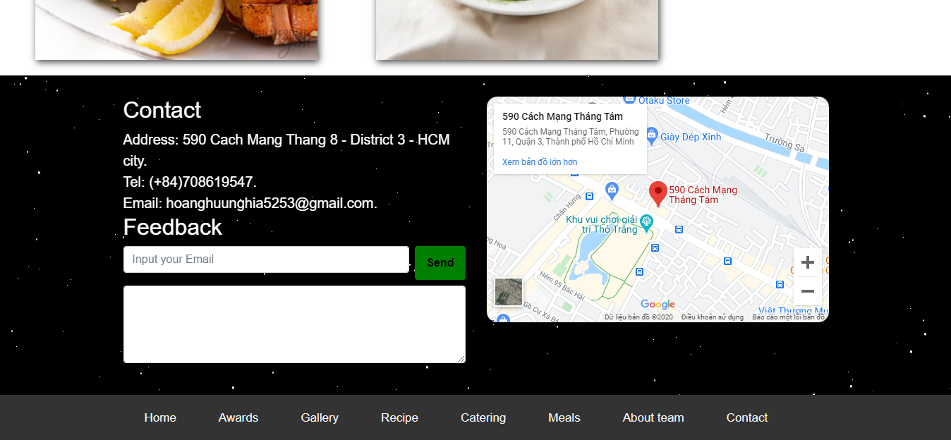

***Top of Lunch page :***

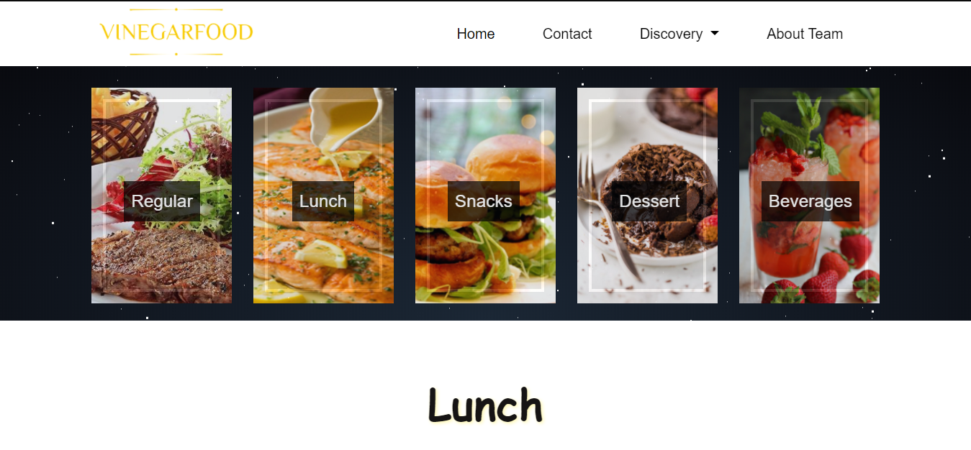

***Bottom of Lunch page :***

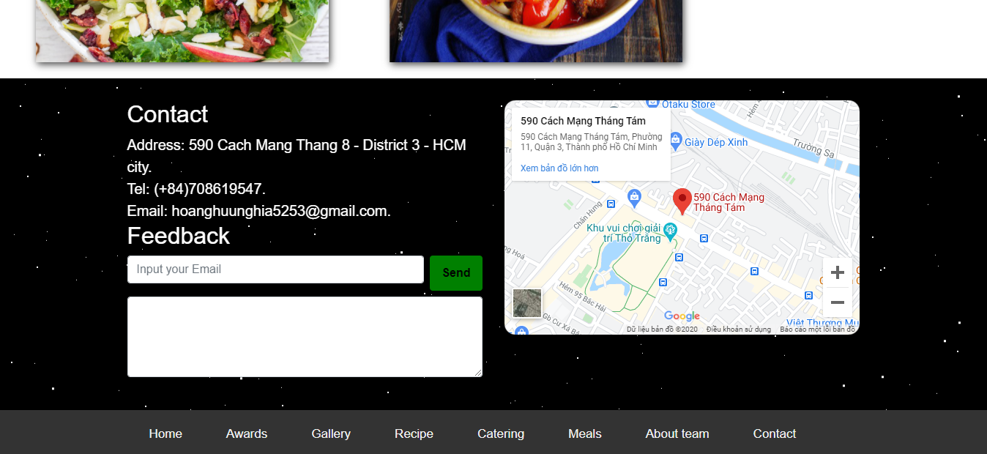

JAVASCRIPT DESCRIPTION

This chapter will provide information about JavaScript function integrated in the website

## Button to top

1. Description: When height of web is scrolled to 350px, the button to top is shown. This button is clicked, the Homepage returns to top of page.
2. Screenshot

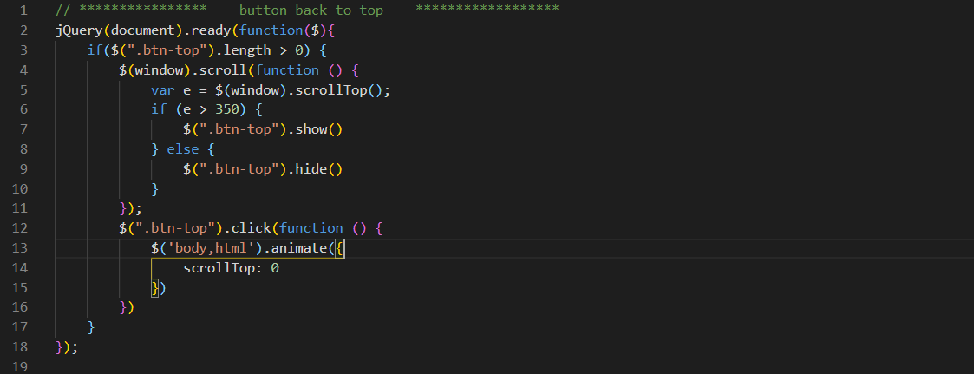

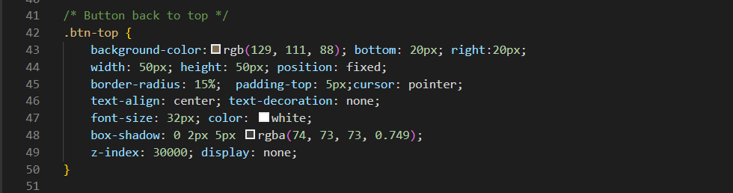

## Bottom Navigation appears when scroll

1. Description: When every page is scrolled, the fixed bottom navigation will appear.
2. Snapshot:

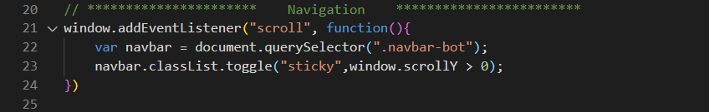

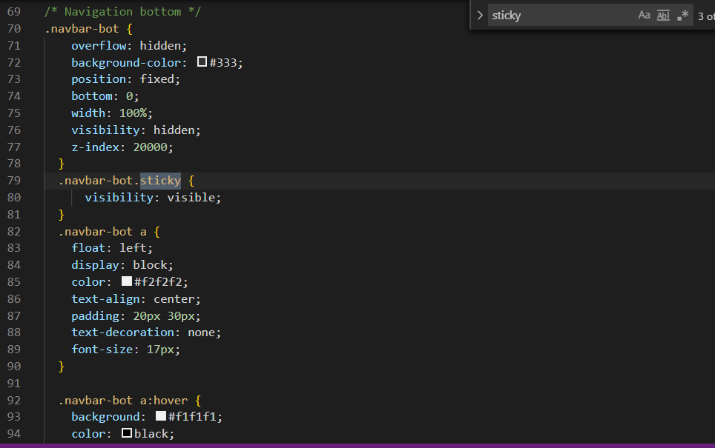

## Bottom Navigation responsive tranforms navigation center

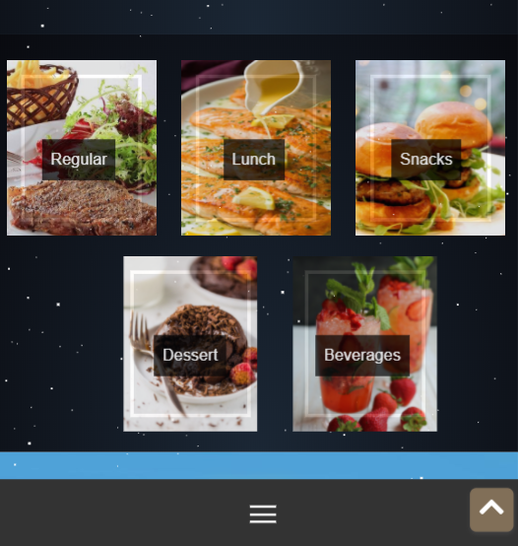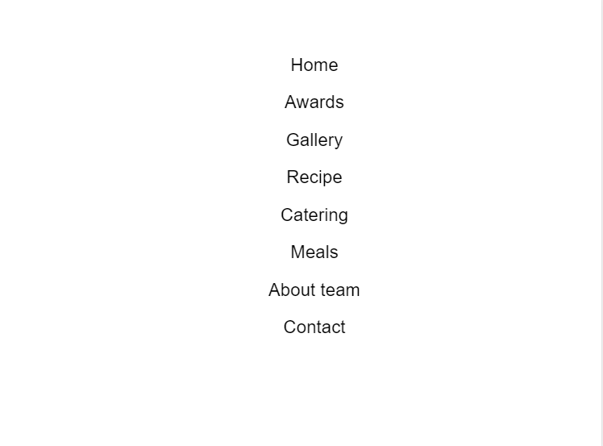

1. Description: After the fixed bottom navigation is responsive like the left above picture, it is clicked the column navigation/ center navigation is shown
2. Snapshot:

Javascript:

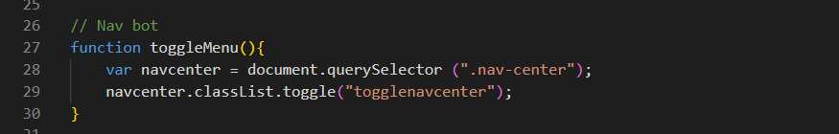

CSS:

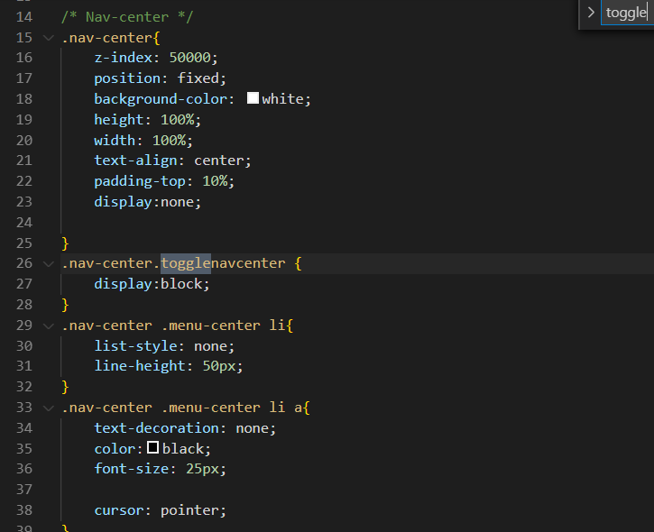

## Addition

* Besides above, we add the build-function, example:
  1. ***WoW js :***
* Description: WoW js makes avatar of members appear by flying into the set position
* Snapshot:

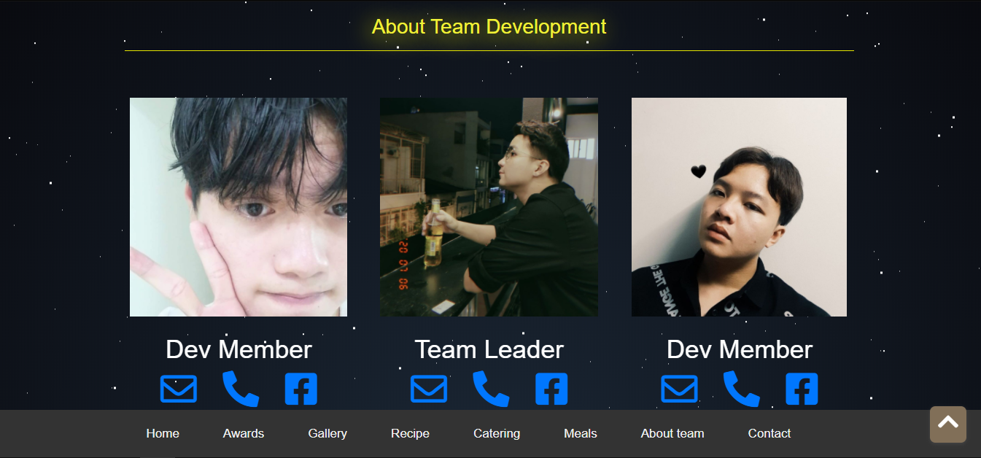



* 1. ***Sweet Alert js :***
* Description : It is used in booking for catering. When click “Book Here” button the “Sweet Alert” pop-up will appear.

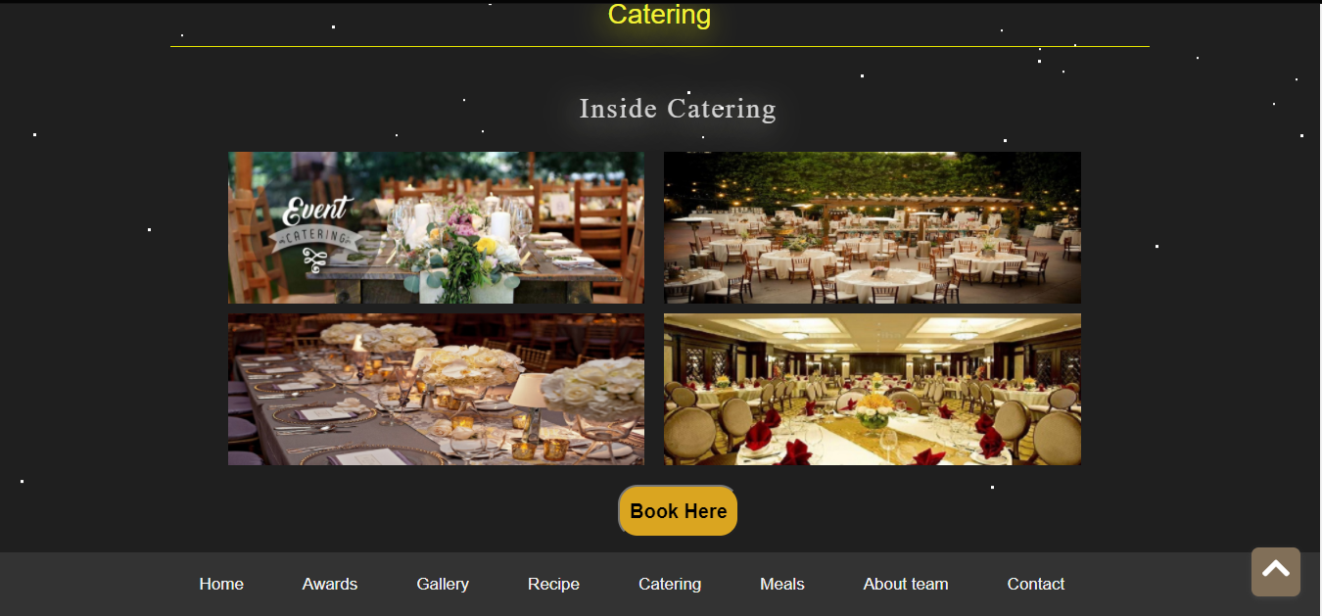

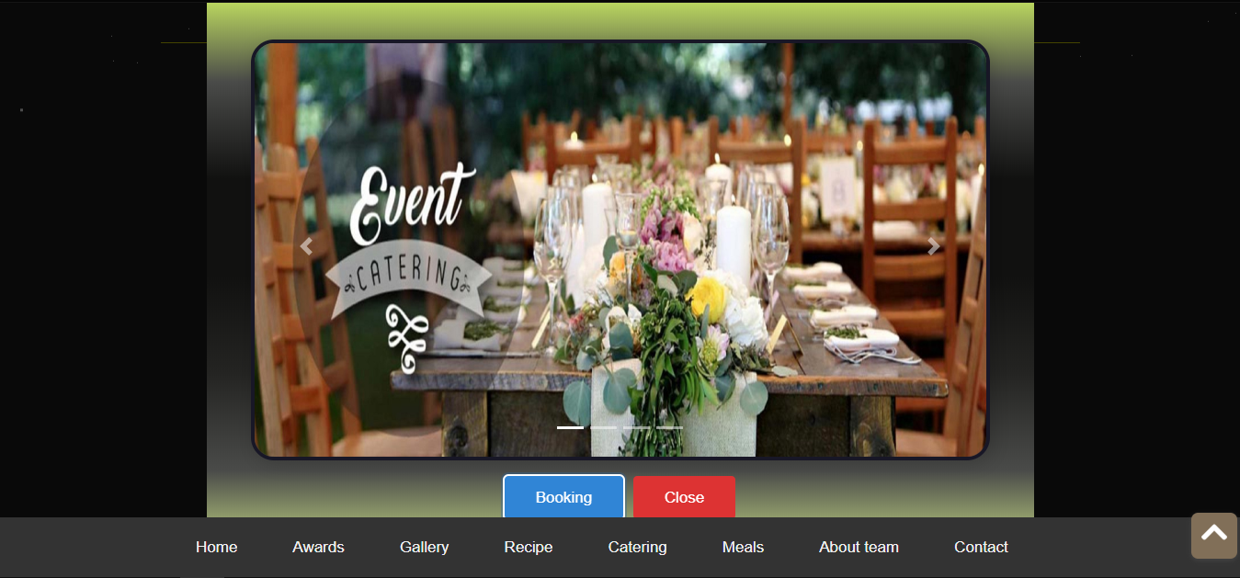

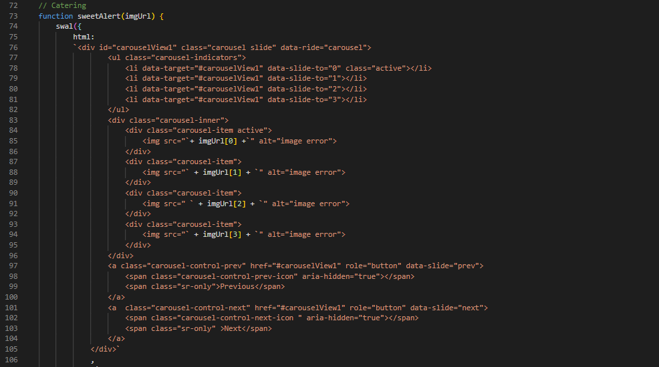

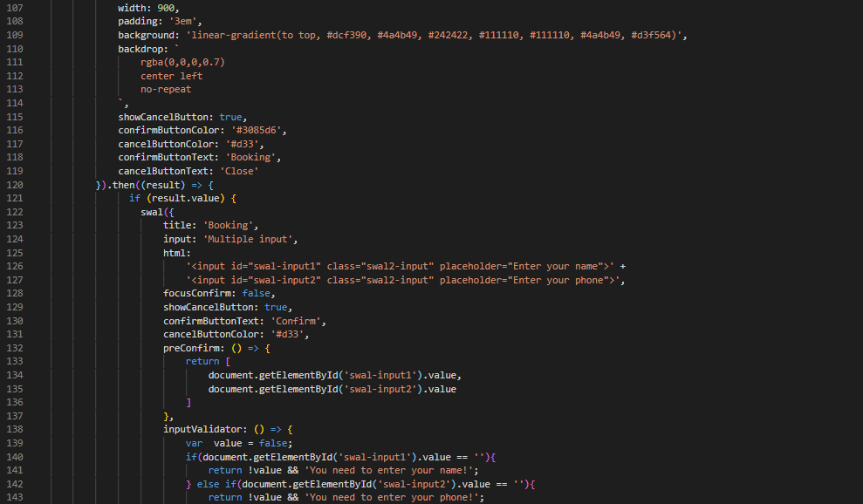

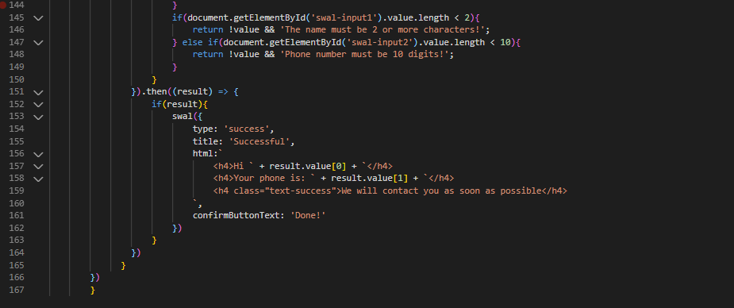

TASK SHEET REVIEW 3

|  |  |  |  |  |  |  |  |
| --- | --- | --- | --- | --- | --- | --- | --- |
| **Project Ref. No:**  **eP/Advertisement Portal Managament System/01** | | **Project Title:** | **Activity Plan Prepared by:** | **Date of Preparation of activity plan** | | | |
| **Sr. No.** | **Task** |  |  | **Actual start date** | **Actual days** | **Teammate name** | **Status** |
| 1 | Homepage | Vinegar Food Restaurant | Nghia | 15/8/2020 | 12 | Nghia | Completed |
| 2 | Awards | 15/8/2020 | 5 | Nghia  An | Completed |
| 3 | Recipe | 15/8/2020 | 5 | Quan Nghia | Completed |
| 4 | Gallery | 15/8/2020 | 7 | Quan Nghia | Completed |
| 5 | Catering | 15/8/2020 | 7 | Nghia | Completed |
| 6 | Contact | 15/8/2020 | 5 | Nghia | Completed |
| 7 | About team | 15/8/2020 | 7 | Nghia | Completed |
| 8 | Regular- Meals | 22/8/2020 | 5 | An  Nghia | Completed |
| 9 | Lunch- Meals | 22/8/2020 | 5 | An  Nghia | Completed |
| 10 | Snacks- Meals | 22/8/2020 | 5 | Quan Nghia | Completed |
| 11 | Dessert- Meals | 22/8/2020 | 5 | Quan Nghia | Completed |
| 12 | Beverages- Meals | 22/8/2020 | 5 | Quan Nghia | Completed |
| 13 | Javascript Description |  |  | 26/8/2020 | 1 | Nghia | Completed |

CHECK REQUIREMENTS OF REPORT

|  |  |  |  |  |
| --- | --- | --- | --- | --- |
| **No.** | **Requirement** | **Available** | **Position in Eproject report** | **Number page** |
| 1 | Acknowledgements | Yes | Acknowledgements | 4 |
| 2 | eProject Synopsis | Yes | Synopsis | 4 |
| 3 | eProject Analysis | Yes | Problem Statement  Customer’s requirements specifications  Scope of the work (in brief) | 5  6  7 |
| 4 | eProject Design | Yes | Mock of website  Website Description | 10  15 |
| 5 | Source Code with Comments | Yes |  |  |
| 6 | User Guide | Yes | in User guide document |  |
| 7 | Developer’s Guide  ( Module Descriptions) | Yes | Javascript Description | 21 |

CHECK REQUIREMENTS OF WEBSITE

|  |  |  |  |
| --- | --- | --- | --- |
| **No** | **Requirement** | **Yes/No** | **References** |
| 1 | Home page must add header section with an image which would show different range of dishes images. | Yes |  |
| 2 | The menu list must be added in one section of the website | Yes |
| 3 | The bottom navigation panel must be designed | Yes |  |
| 4 | Navigation of the website must be made user friendly | Yes |  |
| 5 | All required links are available | Yes | Home – Awards – Gallery – Recipe – Catering – Meals (regular,lunch,snacks,dessert,beverages) – About us – Contact |
| 6 | The type of food must be included | Yes |  |
| 7 | Look and feel must be made user friendly | Yes |  |
| 8 | Uniformity and Navigation must be made smooth throughout the website | Yes |  |
| 9 | There should be a “Contact Us” page which will have the Address of the Company which should be displayed using GeoLocation API (eg. GoogleMaps) and the email address which when clicked will invoke the local mail client from where they can send an email | Yes | “Contact us” is located in footer section of every page |